Contents

GitHub Link 2

Product Description 2

Final Design 3

Target File Structure 7

Implementation 9

Milestone 2 Rubric 12

# GitHub Link

[Jan-elle-Chan/FindTutor (github.com)](https://github.com/Jan-elle-Chan/FindTutor)

# Product Description

This app will help the user to make progress on their learning journey by quickly and easily connecting them with tutors. It does this by giving them options for tutorial type, subject, level and time of day then presents them with options of tutors to choose from including cost. The app also provides study tips, news in education such as curriculum changes, and time tracking with tutors and independent study along with reports on time and cost summaries per subject or per tutor for different time ranges, that is, weekly, monthly etc.

# Final Design

**Home Page**, if the user is not logged in and they click Find a Tutor button they will be taken to **Log In Page**

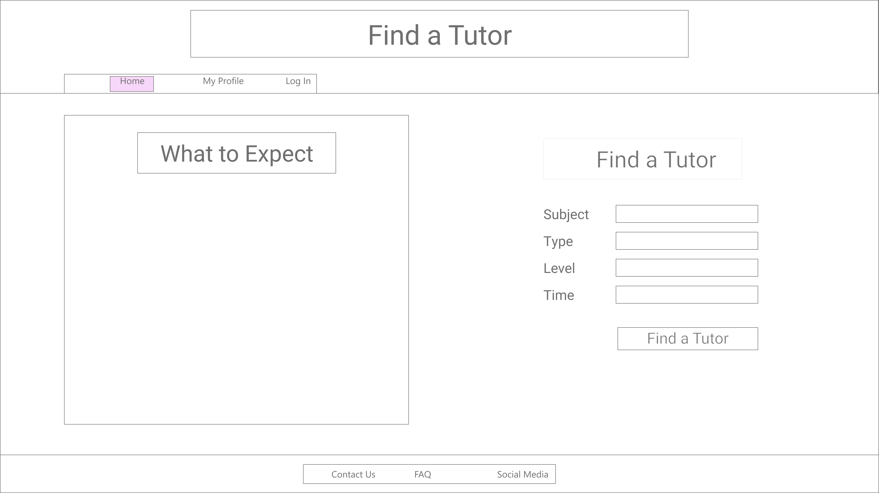

**Log In Page**, user can click on Log In button or Sign Up

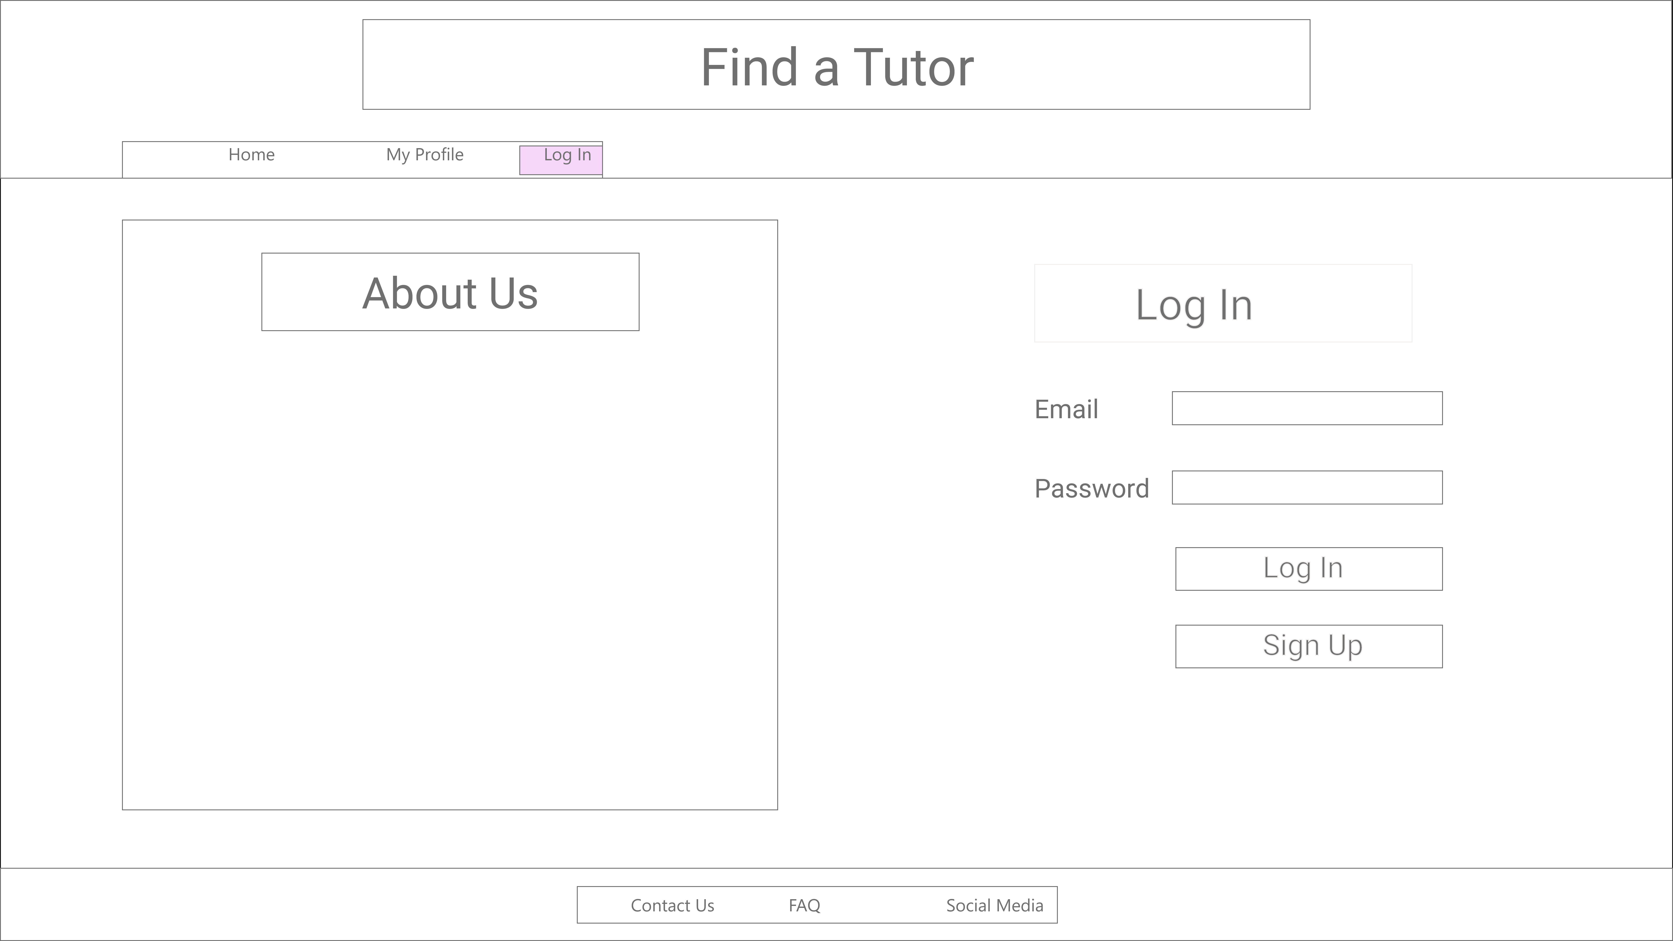

**Sign Up Page**

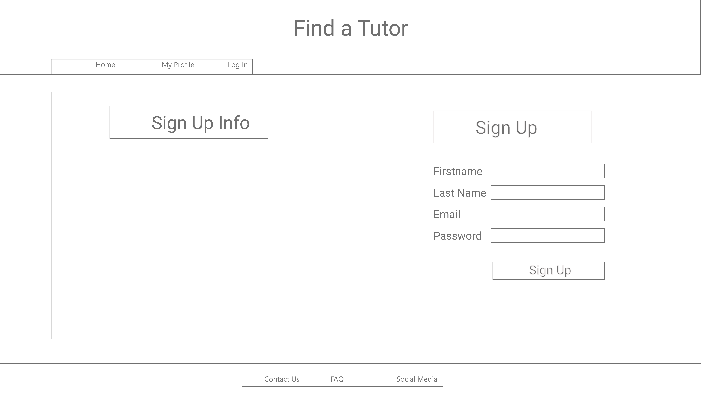

Once user completes find a tutor form, **Search Results Page** will be displayed

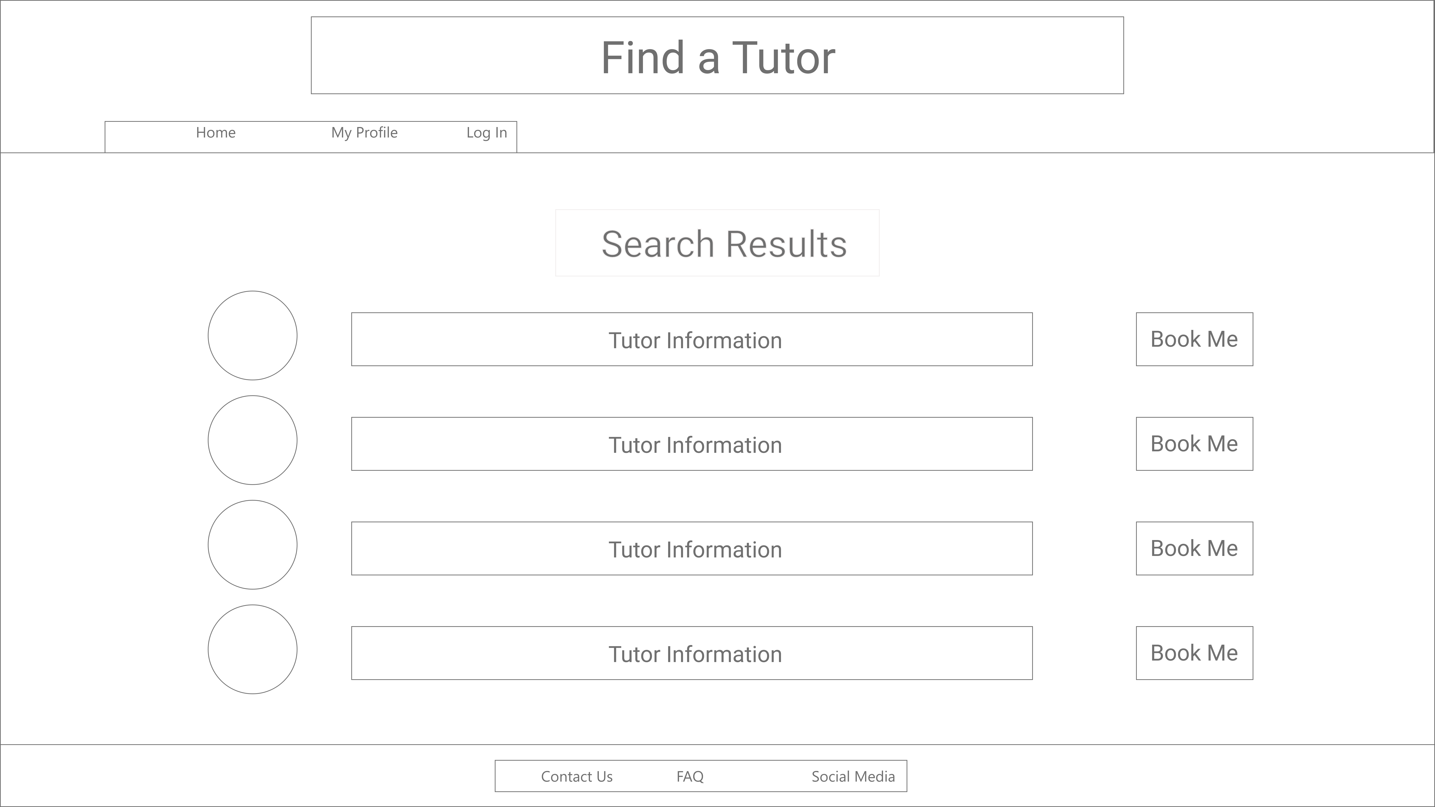

Under My Profile the user can access the tutor they have used in the past. This may not be implemented within the scope of this project.

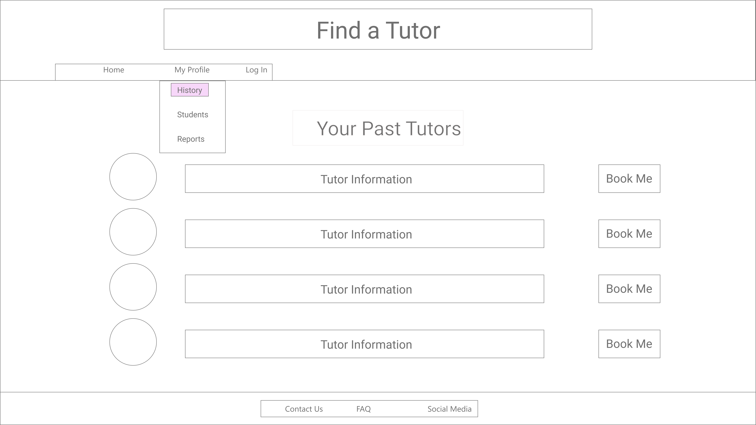

Under My Profile the user can access their students. This may not be implemented within the scope of this project.

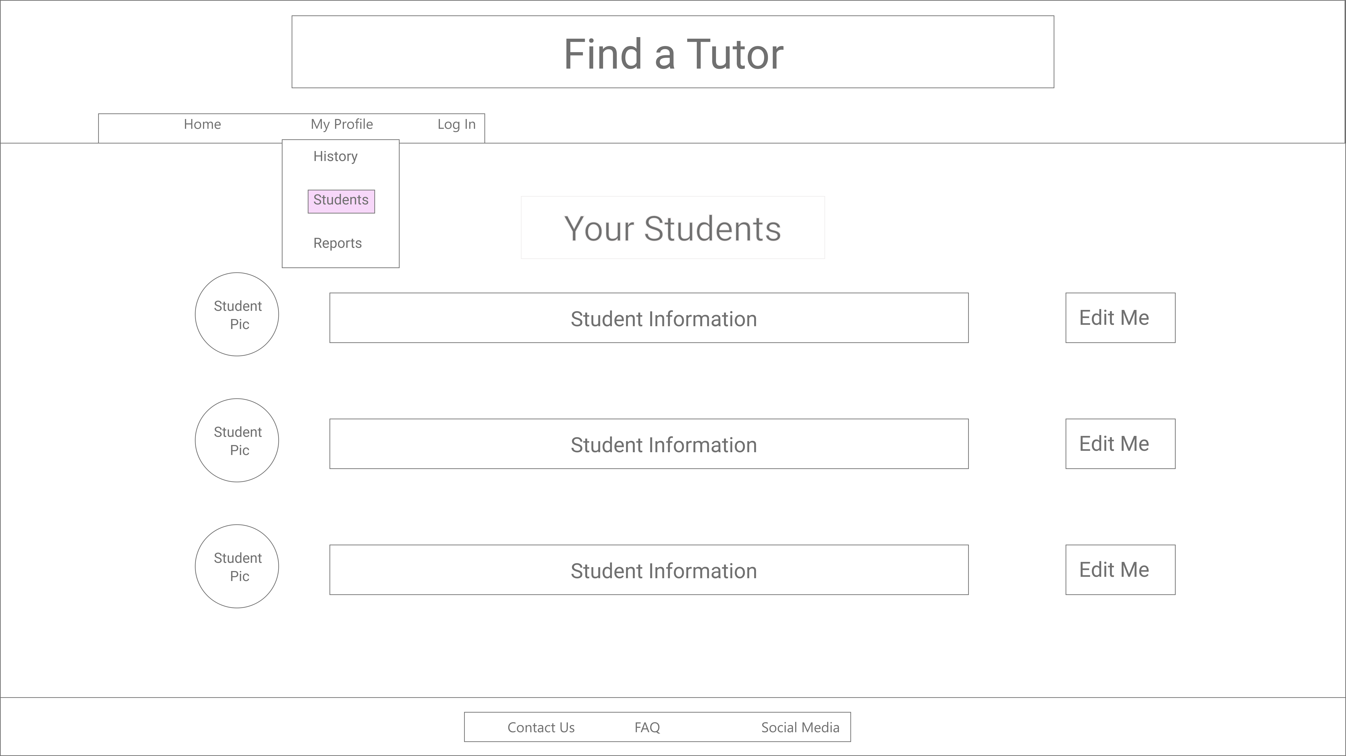

# Target File Structure

|  |  |
| --- | --- |
| Field name | Data Type |
| tutor_ID | integer |
| tutor_first | text |
| tutor_last | text |
| rating | integer |
| location | text |
| subjects | text |
| in_person | boolean |
| online | boolean |

Tutor_Reviews

Key: tutor_ID, review_ID

|  |  |
| --- | --- |
| Field name | Data Type |
| tutor_ID | integer |
| review_ID | integer |
| review | text |

User

Key: user_ID

|  |  |
| --- | --- |
| Field name | Data Type |
| user_ID | integer |
| email | text |
| password | text |
| postal_code | text |

Student

Key: user_id / student_number

|  |  |
| --- | --- |
| Field name | Data Type |
| user_ID | integer |
| student_number | integer |
| DOB | date |
| current_level | text |

Tutorial

Key: user_ID, tutor_ID, session

|  |  |
| --- | --- |
| Field name | Data Type |
| user_ID | integer |
| tutor_ID | integer |
| session | date |

# Implementation

The following screenshots are of the initial implementation of the front end. Some changes that need to be made include following:

* Button sizes
* Font legibility
* Contrast
* Accessibility
* Images of tutors
* More content

Home Page/ Find a Tutor

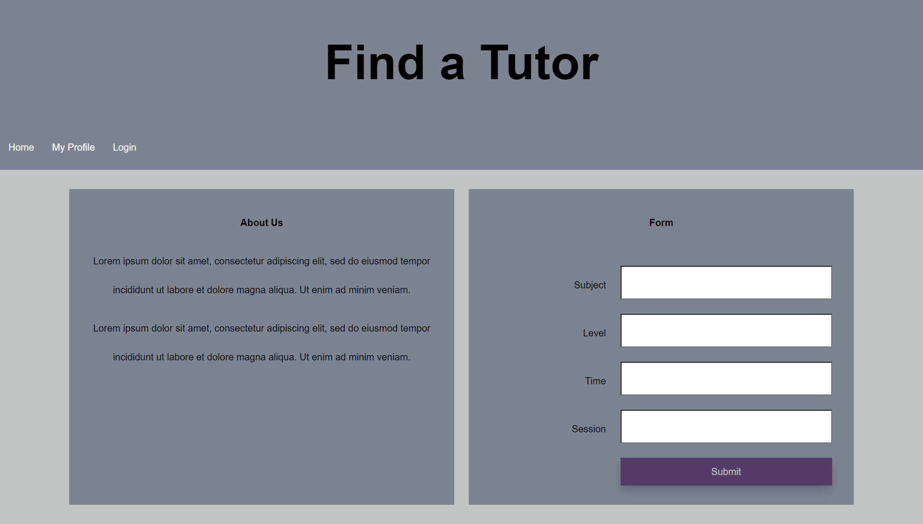

My Profile >> History Page

The Search Results page will be similar to this page.

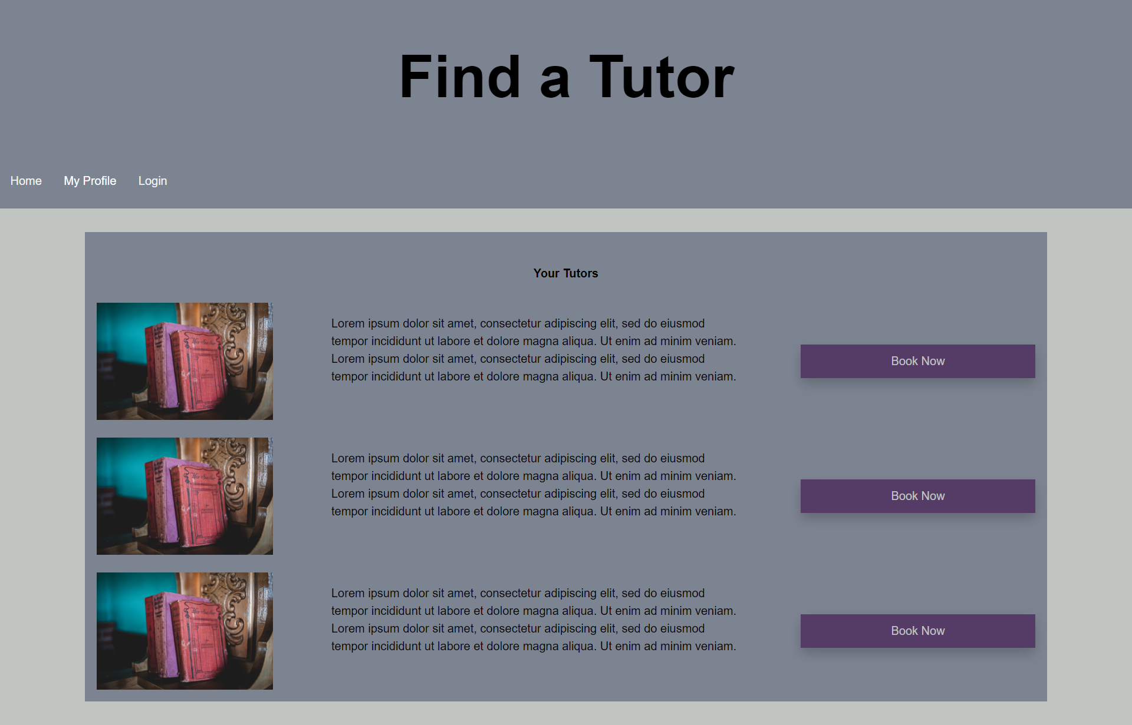

Login Page

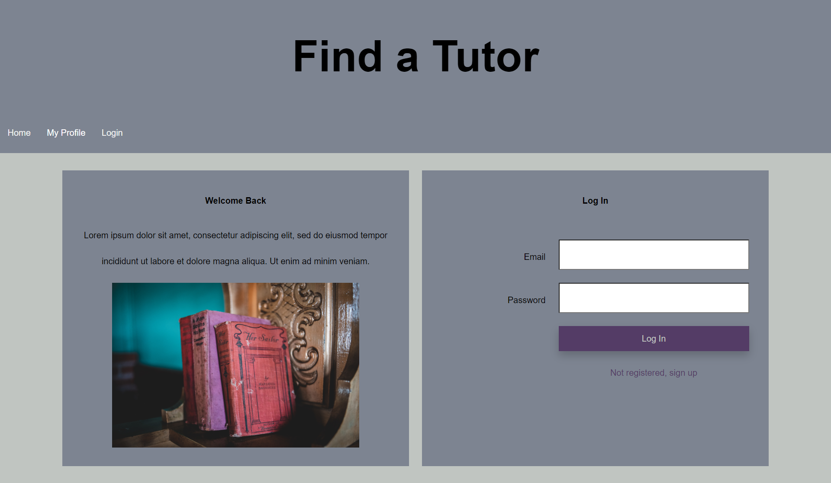

Sign Up Page

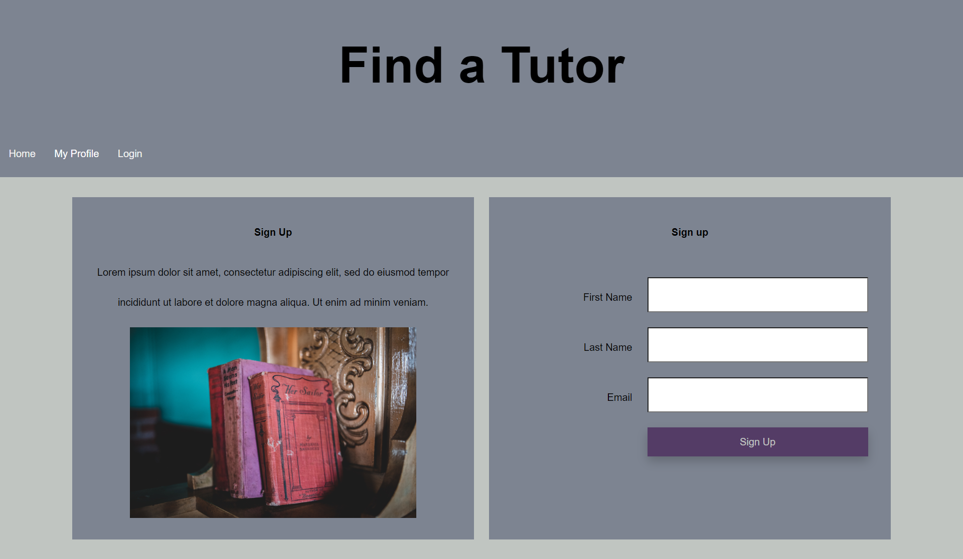

# Milestone 2 Rubric

INSTRUCTIONS: Please fill out the following form and submit it on BrightSpace. Choose only one of the corresponding numbers in your answer for sections A-F. Answer the questions in section G in sentence form.

Please total your self-evaluation score at the bottom of the rubric. **17/ 20**

1. Code Quality
2. - Nothing - No submission
3. - Below Expectations - Code renders but the code is unreadable
4. - Meets Expectations - Good formatting and uses naming conventions but can be improved
5. - Exceeds Expectations - Code is exceptionally clean and best practices are used

**Your Answer:3**

1. Content
2. - Nothing - No submission
3. - Below Expectations - Content not related to assignment or project (lorem ipsum, for example)
4. - Meets Expectations - Content is related to assignment or project and gets the point across
5. - Exceeds Expectations - Content is exceptionally detailed and well put together

**Your Answer: 2**

1. Layout / Organization
2. - Nothing - No Submission
3. - Below Expectations - Long sections of code with no divisions or random code layout
4. - Meets Expectations - Code that is modular and divided into sections; subprograms and functions
5. - Exceeds Expectations - Code is exceptionally well organized. **Your Answer: 3**
6. Comments/Commits/Documentation
7. - Nothing - No Submission
8. - Below Expectations - Excessive, unnecessary, and irrelevant remarks; infrequent commits; missing documentation
9. - Meets Expectations - Comments identify authorship and code's intention
10. - Exceeds Expectations - Comments and documentation are clear succinct; wizardry points are explained

**Your Answer: 3**

1. Rendering and Interface
2. - Nothing - Page does not load or render
3. - Below Expectations - Page renders, but has errors and/or has apparent design issues
4. - Meets Expectations - Page renders and produces no errors; Interface logically laid out
5. - Exceeds Expectations - Page renders and displays properly for multiple screen sizes and browsers; Exceptional usability

**Your Answer: 2**

1. Process
2. - Nothing - Project not attempted
3. - Below Expectations - code and documents not added to repository at correct times (all at once, for example)
4. - Meets Expectations - code tested regularly, pushes throughout milestone period, implementation targets met
5. - Exceeds Expectations - all design goals accomplished, submissions organized, instructions carefully followed, steps thoroughly documented

**Your Answer: 2**

1. Self Evaluation Questions (half point each):
   1. How much time did you spend on this assignment/project? ***10 hrs***
   2. How difficult did you feel this project was? Easy, moderate, difficult?

***Moderate to difficult***

* 1. What challenges did you come across while working on this project? ***Minor things like code not working as expected, deciding how to represent search results without the actual results available with no back-end yet***

4. What things would you like to learn more about after having worked on this assignment? ***I need to learn how to implement the database and link it***

**Total Score 2**

***Total Score : 17/20***